Cwrt Rawlin Primary School
Apps for Apple Devices: iPads, Macs, iPhones, iPods
These are some of the many apps that your children will be using in school to enhance their learning. You may wish to use them at home as well, as they are educational and fun to use. They may also be useful to use to enhance or facilitate certain types of homework.
If you have any questions about any of the apps, please see your child’s class teacher for further information.

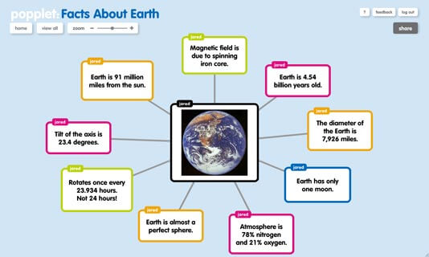
Popplet
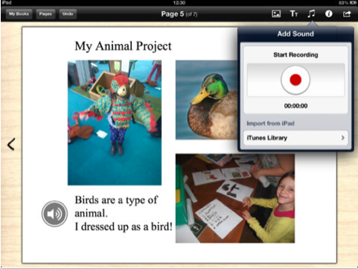
Book Creator
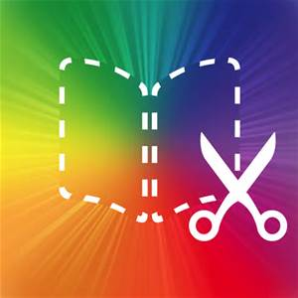

iMovie Puppet Pals
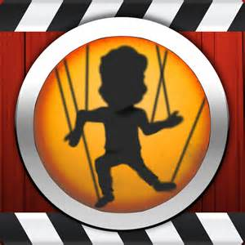
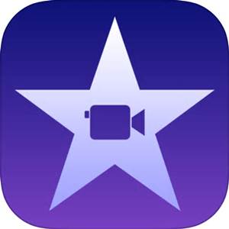

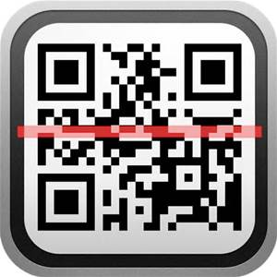
QR codes Scratch Kids /Scratch
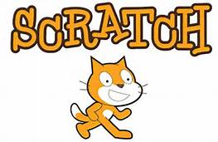

Comic Life
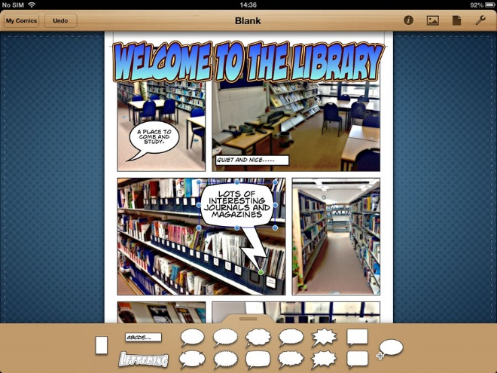

And many more to come………

