CWRT RAWLIN PRIMARY SCHOOL
YSGOL GYNRADD CWRT RAWLIN


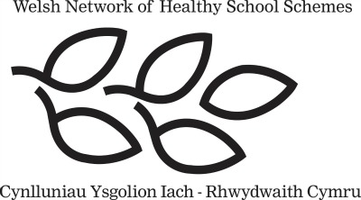

SUSTRANS ACTIVE JOURNEYS SCHOOLS PROGRAMME

8th February 2017

Dear Parent/Guardian s,

As a part of the Active Journeys programme, we will be holding the ‘Big Shift’ event in school next week. The event will run from Monday 13th February – Friday 17th February 2017 and its purpose is to increase the amount of pupils walking, cycling and scooting to school. The Big Shift will also help promote our Healthy Schools and Eco Schools aims and missions.

At Cwrt Rawlin, we want to challenge and motivate the school community to travel more actively. The challenge sets schools individual targets, based on how pupils currently travel - helping them make a Small Step, Big Stride or Giant Leap in how pupils make the school journey.

All children are encouraged to travel to school as actively as possible next week, this includes:
- Walking
- Cycling
- Street Surfing
- Scootering
- Roller Blading
- Or any other way they can think of that allows them to actively travel to school.

Our pupils’ safety is paramount, so we would like the pupils to adapt the ‘Road Safety Rules’ and ‘Be Bright, Be Seen’ rules of the road on their journeys to school.


Please feel free to take pictures of your children dressed in their reflective clothing or pictures of them on their journeys to school. We would love to display some of them. You will also be able to see lots of pictures of ‘The Big Shift’ on our Twitter page!

Kind regards,


Miss K. Morgan Mr J. Johns
Active Journeys Co-ordinator Healthy Schools and Eco Schools Co-ordinator

