Cwrt Rawlin Primary School
Ysgol Gynradd Cwrt Rawlin

Anti-Bullying Policy
DEFINITION
The Welsh Government’s definition of bullying, as set out in ‘Respecting Others: Anti-Bullying Overview (2011)’ states that there are many definitions of bullying, but most consider it to be:
• Deliberately hurtful (including aggression);
• Repeated often over a period of time, while recognising that even a one-off incident can leave a learner traumatised and nervous of future recurrence; and
• Difficult for victims to defend themselves against.

INTRODUCTION
We acknowledge the School Standards and Framework Act 1998 that clearly states that all maintained schools must have in place an Anti-Bullying Policy that outlines procedures in order to prevent bullying among pupils.
We strive to provide a safe, secure, caring and friendly school environment for all the children in order to protect them from those who wish to deliberately hurt them either physically or emotionally.
Bullying is a whole school issue. We will not tolerate any form of bullying and all incidents of bullying will be dealt with promptly and effectively.
We work closely with the School Council so we can hear their views and opinions as we acknowledge and support Article 12 of the United Nations Convention on the Rights of the Child that children should be encouraged to form and to express their views.

BULLYING

The anti-bullying policy complies with the Human Rights Act 1998 and Equality Act 2010.
As a school we take bullying and its impact seriously. Pupils and parents should be assured that known incidents of bullying will be responded to.
Bullying will not be tolerated. The school will seek ways to counter the effects of bullying that may occur within the school or in the local community. The ethos of our school fosters high expectations of good behaviour and we will consistently challenge any behaviour that falls below this. All members of the school community share a collective responsibility for tackling bullying should it occur and in working together to promote positive behaviour.

Aims:
Our policy is a working framework to support our whole school ethos which is to ensure children feel safe, secure, confident and happy. It is designed to prevent bullying behaviour wherever possible, to respond consistently in line with agreed procedures and to provide support to those involved as appropriate. Our children’s health and well-being is of paramount importance, as is a safe and secure environment where all children can develop, grow, play and achieve their full potential without fear or anxiety.
Bullying is a whole school issue and a multi-faceted approach is the most effective.
Objectives:
- All governors, teaching and non-teaching staff, pupils and parents should have an understanding of what bullying is.
- All governors and teaching and non-teaching staff should know what the school policy is on bullying, and follow it when bullying is reported.
- All pupils and parents should know what the school policy is on bullying, and what they should do if bullying arises.
All of us have encountered bullying at some point in our lives, but we deal with it differently. The aim of this policy is to work together to ensure that our school is a safe place for children and adults to be; whether the school community is directly or indirectly affected by bullying or not.

What is bullying?
Bullying is deliberately hurtful and designed to cause distress. It is usually repeated over a period of time and is difficult for the person being bullied to defend themselves against. It involves an imbalance and abuse of power and is not age dependent. It may have a racist or discriminatory motivation and can focus on ethnicity, culture, class, religion, learning difficulties, gender, sexuality, long term health conditions and disability. It may be based on small differences between children which are not always clear to us ad may shift and develop as relationships change. Bullying behaviour may be shown by individuals or groups. It may not always be clear who is manipulating the behaviour we see. Some children can be “provocative victims” e.g. by behaving in a tiresome way which eventually triggers a response which may then be seen to be bullying.
Bullying is not falling out with friends, choosing not to play with someone, one off aggressive behaviour such as a fight between children who disagree, accidental physical contact, or the proportionate rough and tumble of everyday playground life.

Bullying can be:
Emotional | Being unfriendly, excluding, tormenting (e.g. hiding books, threatening gestures).
Physical | Pushing, kicking, biting, hitting, punching or any use of violence.
Racial | Racial taunts, graffiti, gestures.
Sexual | Unwanted physical contact or sexually abusive comments.
Homophobic | Because of, or focussing on the issue of sexuality.
Direct or indirect Verbal | Name-calling, sarcasm, spreading rumours, teasing.
Cyber bullying | All areas of internet, such as email and internet chat, Twitter, Facebook misuse. Mobile threats by text messaging and calls. Misuse of associated technology, i.e. camera and video facilities, i-pad, games console.

Bullying can take place in the classroom, playground, toilets, on the journey to and from school, on residential trips and cyberspace. It can take place in group activities and between families in the local community.
Perpetrators and Victims
Bullying takes place where there is an imbalance of power of one person or persons over another.
This can be achieved by:
- The size of the individual
- The strength of the individual
- The numbers or group size involved
- Anonymity – through the use of cyber bullying or using e-mail, social networking sites, texts etc.

Why is it important to respond to bullying?
Bullying hurts. No one deserves to be a victim of bullying. Bullying has the potential to damage the mental health of a victim. Everybody has the right to be treated with respect. Pupils who are bullying need to learn different ways of behaving.

Implementation
- All staff need to be aware of children who are more likely to be bullied –
- Children who have a different appearance
- Have a different cultural, racial or religious background.
- Those who appear to be materially very rich or very poor.
- Children who are very clever or who work hard.
- Passive children.
- Children who are vulnerable e.g. pupils with additional needs, new pupils, younger/smaller, few friends, problems outside the school environment.
All staff need to be aware of children who are more likely to carry out the bullying.
- All staff should be sensitive to and aware of possible signs of a child being bullied. This might include –
- Displays of uncharacteristic unhappiness.
- Deterioration in schoolwork.
- Increase in anxiety and reluctance to attend school.
- Unexplained minor injuries.
- Uncharacteristic desire to be with adults.
- Loss of/damage to personal property.
- Bringing large amounts of money to school.

- We will address the policy through a cross-curricular approach, but will be specifically addressed in assemblies, collective worship, PSHE / Jigsaw sessions. Liaison with the Police and groups such as NSCPCC/Childline can also support this. Areas to be addressed include –
- Different types of bullying.
- Why bullying happens.
- Why bullying is wrong.
- How bullying works.
- Strategies and skills to avoid and combat bullying.

- Key strategies to reduce bullying should be encouraged, including –
- Cooperative group work.
- Shared tasks.
- Trust building exercises.
- Co-operative games.
- Problem solving.
- Discussion groups.
- Role play and simulations.

Procedures
Stage 1 (Teacher Concern)
- Teacher reports to the Head Teacher of Deputy Head Teacher
- Apology to victim – verbal.
- Apology to victim – written.
- Appropriate consequences.
- A possible loss of privileges.
- Informing parents.
- Bullying can be persistent so incidents will be followed up to check that there is no recurrence – within 2 weeks and during the following half-term. If pupils expect a follow up, it will be less likely to recur.
- Incidents of bullying will be recorded in the Class Incident Record identifying the date, name of child, concern, context and location, action taken. A copy of the incident details will be given to the Head Teacher or Deputy Head Teacher, who will keep a whole school record. Monitoring
incidents of bullying enables a school to identify patterns of behaviour and the extent of bullying, and then take pro-active steps to challenge it.

Stage 2 (School Action)
- Class teacher reports to ALNCo and may discuss with the Head Teacher.
- Class teacher, ALNCo, Head Teacher, Deputy Head Teacher or suitably experienced staff personnel counsel the child formally (both victim and the perpetrator).
- Parents are involved in counselling.
- Pupils involved (both victim and the perpetrator) may be offered regular pastoral support and intervention to support their social emotional and mental well being. For the bully, this would aim to help him/ her understand and manage their emotions, make responsible decisions, build and maintain relationships, and understand and empathise with others.
- Incidents of bullying will continue to be recorded, identifying the date, name of the child, concern, context and location, action taken. A whole school record will be kept in the Head Teacher’s office.

Stage 3 (School Action Plus)
- Head Teacher / Outside Agency / ALNCo implement clear strategies to correct behaviour.
- Parents work in tandem with the school.
- Governors may be involved.
- Suspension and/or exclusion may be considered.

The Role of the Pupils
- Pupils are encouraged to tell someone they trust if they are being bullied and, if the bullying continues.
- Pupils will be encouraged to share their views about a range of school issues, including bullying e.g. surveys (PASS), PSHE sessions, School Council Meetings.
- The School Council has developed its own anti-bullying codes:
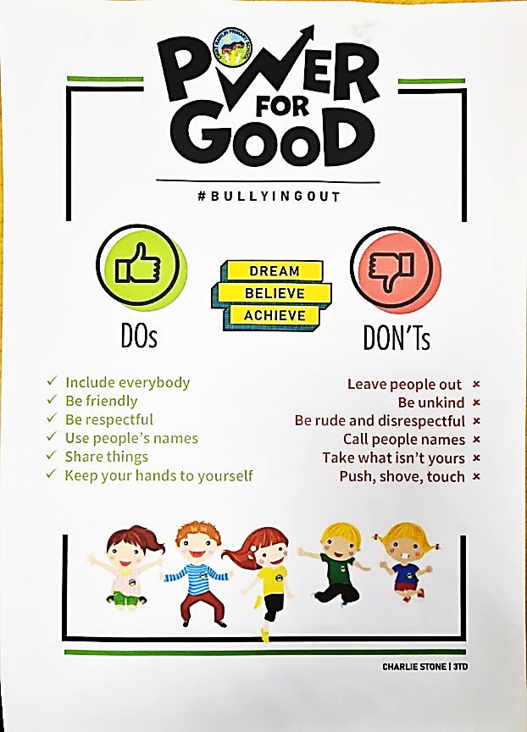
Nursery to Year 2: Year 3 to Year 6:

The Role of the Teacher and Support Staff
- To take all forms of bullying seriously.
- Teachers keep their own records of all incidents of bullying in their classroom and other areas of the school. If the teachers are aware of an act of bullying, they will initially investigate it themselves, then report it to the Head Teacher or Deputy Head Teacher. Teachers and support staff will follow the agreed school procedure immediately.
- Teachers should use a range of methods to help to prevent bullying and establish a climate of trust and respect for all. Drama, discussion, role-play and stories can be used within the formal curriculum to help pupils to understand the different elements associated with bullying. Assembly and PSHE sessions can be used to raise self-esteem and create a positive anti bullying ethos.
- Teachers will refer to and make regular links to the UNCRC articles to ensure all pupils understand their right to be safe. Teachers will create a classroom ethos that promotes pupil’s exercising their rights.

The Role of the Head Teacher
- To implement the school anti-bullying procedures and to ensure that all staff are aware of the school policy and know how to identify and deal with incidents of bullying. The Head Teacher will keep records of incidents of bullying. The Head Teacher will, on request, report to the Governing Body about the effectiveness of the anti-bullying policy.
- The Head Teacher ensures that all children know that bullying is wrong and will not be tolerated in this school. This can be reinforced at assemblies or when incidents occur.
- To ensure that all staff receive sufficient training to enable them to identify and deal with all incidents of bullying.
- The Head teacher sets the school climate of mutual support and positive relationships, where every member of the school community feels valued and respected.

The Role of the Governors
- To support the Head Teacher in all attempts to eliminate bullying from our school. Any incidents of bullying must be taken seriously and dealt with appropriately.
- The Governing Body will monitor incidents of bullying and review the effectiveness of this policy regularly. The Governors, therefore require the Head Teacher to keep accurate records of all incidents of bullying and to report on the effectiveness of school anti-bullying procedures.
- To investigate and respond within ten days to any request from dissatisfied parents regarding incidents of bullying. In all cases the Governing Body will notify the Head Teacher, request an investigation and a report to an appropriate representative of the Governing Body.

The Role of the Parent/Guardians
- Parents who suspect that their child is either being bullied or is the perpetrator of bullying should report to the class teacher immediately. If they are not satisfied with the response, they should contact the Head Teacher. If they remain dissatisfied, they should follow the school complaints procedure.
- Parents have a responsibility to support the school’s anti-bullying policy, actively encouraging their child to be a positive member of the school community.
Monitoring and Review
- This policy will be monitored on a day-to-day basis by the Head Teacher and the Deputy Head Teacher, who report to the Governing Body on request, about the effectiveness of the policy.
- The anti-bullying policy is the responsibility of the Governors, who will review its effectiveness annually. Recorded incidents will be discussed with the Head Teacher and analysed to identify patterns.
- The policy will be reviewed every year or earlier if necessary.

Help Organisations:
Bullying on line – www.bullying.co.uk
Kidscape: 020 7730 3300
Childline: 0800 1111
NSPCC: 0808 800 5000
Bullying UK: 0808 800 2222
National Bullying Helpline: 0845 22 55 787
@bullyinguktwitter
Bullybusters: 0800 169 6928

Next review: January 2025

