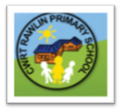
CWRT RAWLIN PRIMARY SCHOOL
YSGOL GYNRADD CWRT RAWLIN



SUSTRANS ACTIVE JOURNEYS SCHOOLS PROGRAMME
BLING YOUR RIDE

30th November
Dear Parent/Guardian,

As a part of the Active Journeys programme, we will be holding the ‘Bling Your Ride’ event in school. On Friday 7th December we will be holding a Winter theme ‘Bling Your Ride’ competition. As part the theme, we ask pupils to decorate their scooter or bike to represent a part of winter, whether it be winter clothing, winter weather or Christmas. There are some examples of how the pupils could ‘bling’ their bike or scooter below:

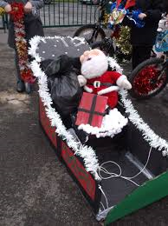
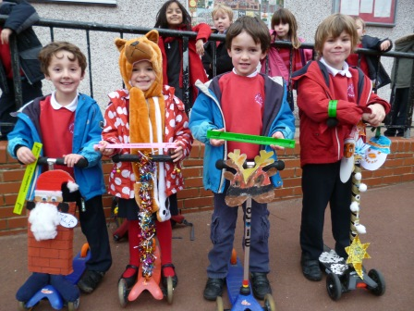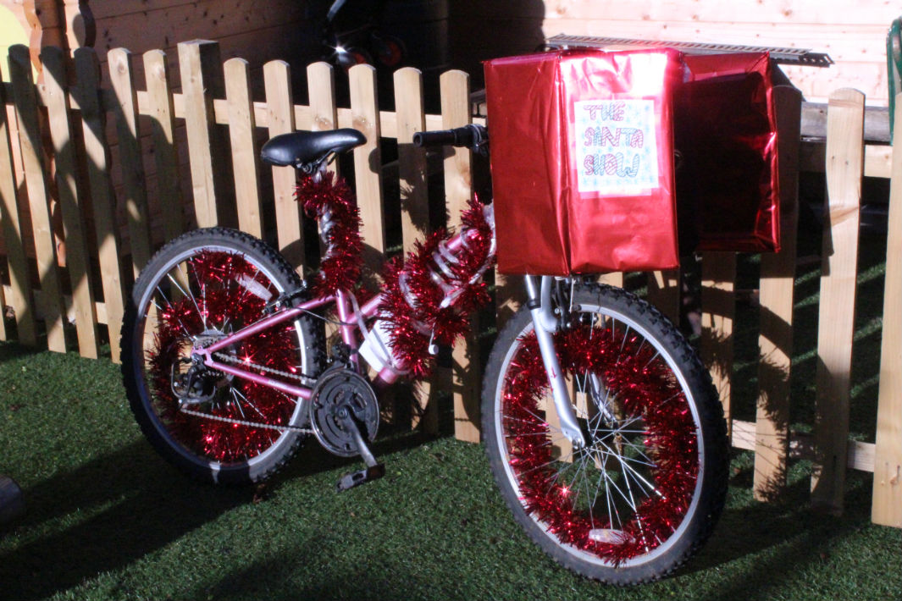
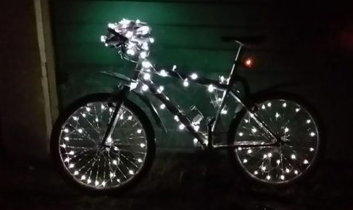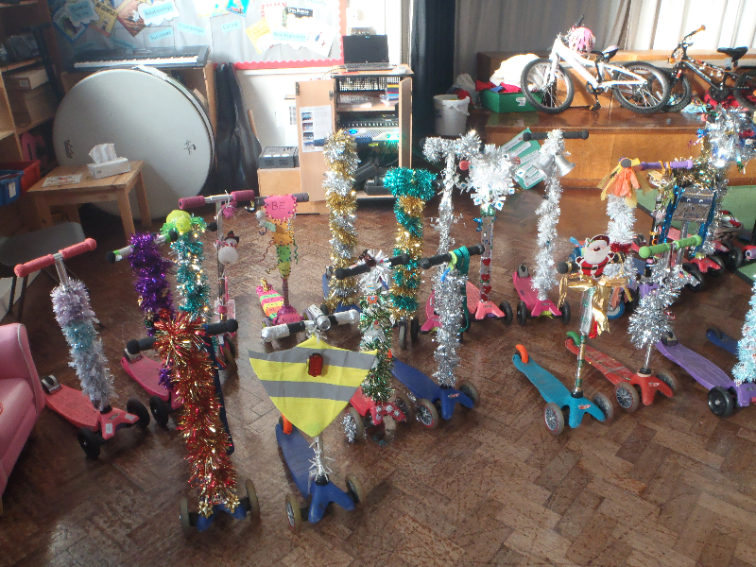

We would like the children to be as involved as possible in ‘blinging’ their ride. There will be prizes for the winners of the ‘Bling Your Ride’ competition.

Our pupils safety is paramount, so we would like the pupils to adapt the ‘Road Safety Rules’ and ‘Be Bright, Be Seen’ rules of the road on their journeys to school.

Please feel free to take pictures of your children on their journeys to school. We would love to display some of them. You will also be able to see lots of pictures of ‘Bling Your Ride’ on our Twitter page!

Kind regards,
Miss K. Morgan
Active Journeys Co-ordinator

